DevelopersHub Corporation Red
Teaming

Week 2 : Task

Week 02: Remediation & Patching
Objective : To provide technical solutions and code-level patches for the vulnerabilities identified in Week 01.

Submitted By :
Usman Ghani

DHC ID:
2502

Instructor:
Faizan Khan

Week :
Red Team - Week 2

​Date:
April 14, 2026

- EXECUTIVE SUMMARY (REMEDIATION PHASE)

The objective of Week 02 is to address and patch the security vulnerabilities identified during the initial penetration testing phase (Week 01). This report focuses on implementing "Defense in Depth" strategies, specifically targeting SQL Injection and Cross-Site Scripting (XSS) at the source code level.

  - Vulnerability Identification

The login module of the application was found to be vulnerable to SQL Injection due to lack of input sanitization in the email and password fields.

  - Root Cause Analysis

The backend query was using direct string concatenation to process user inputs, allowing attackers to manipulate the SQL logic using payloads like ' OR 1=1 --.
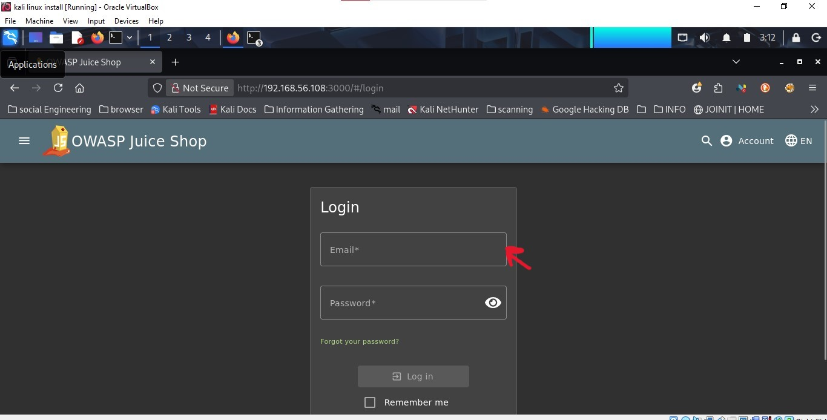
  - Proposed Solution: Prepared Statements

The most effective way to prevent SQLi is using Prepared Statements (Parameterized Queries). This ensures that the database treats user input strictly as data and never as executable code.

  - Vulnerable Code

$query = "SELECT * FROM users WHERE email = '" . $user_input . "'";
Secure Code (Patch)
$stmt = $pdo->prepare('SELECT * FROM users WHERE email = ?');
$stmt->execute([$user_input]);

- CROSS-SITE SCRIPTING (XSS) REMEDIATION

  - Vulnerability Identification

The search functionality was identified as vulnerable to Reflected XSS, where malicious scripts could be executed in the victim's browser via the URL or search input.

  - Root Cause Analysis

The application fails to encode user-supplied data before rendering it back to the HTML page, allowing <script> tags to be interpreted by the browser.

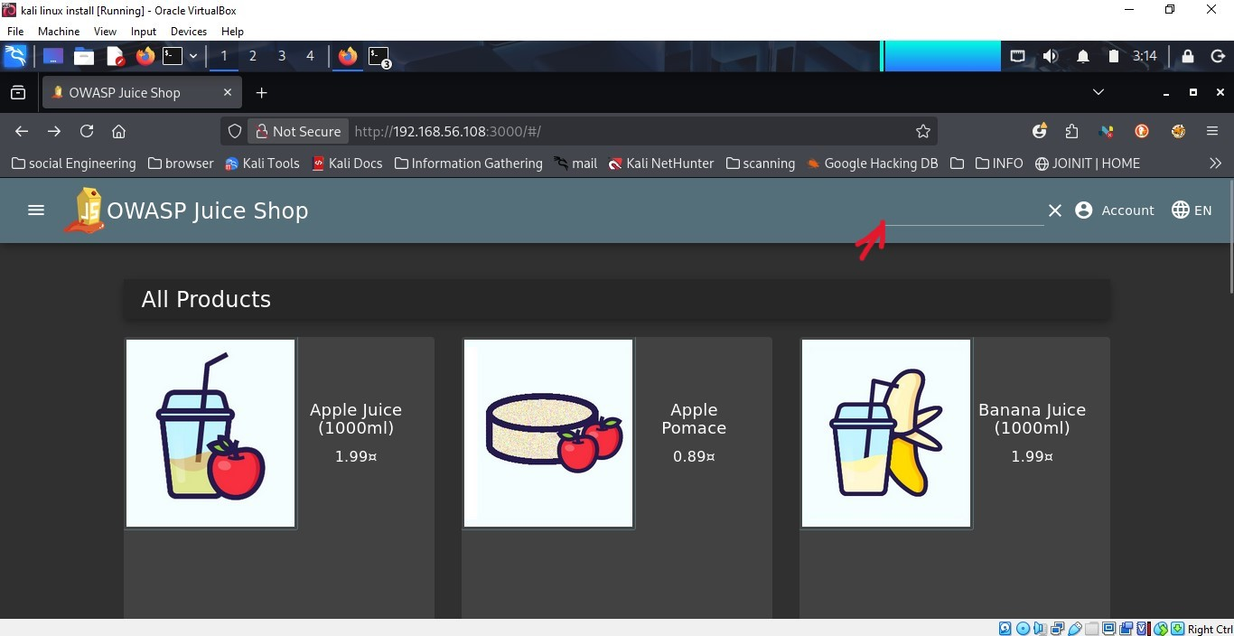

  - Proposed Solution: Output Encoding & Sanitization

To mitigate XSS, all user-supplied data must be encoded into HTML entities before being displayed.

Encoding Examples :

< becomes &lt;
> becomes &gt

- VERIFICATION AND TESTING

Post-remediation testing was conducted to verify the patches :

SQLi Test : The ' OR 1=1 -- payload no longer grants access and returns a "401 Unauthorized" error.

XSS Test: Script payloads are now displayed as plain text on the screen, and no alert box is triggered.

- FINAL CONCLUSION

By implementing Prepared Statements and Output Encoding, the critical security risks have been mitigated. It is recommended to perform regular automated scans to ensure no new injection points are introduced in future updates.

